EXPENSE TRACKING SYSTEM

IT23431 – MongoDB Essentials

Submitted by
NOORUNNISA I – 241001158
SAHANA B– 241001209

OF
BACHELOR OF TECHNOLOGY IN INFORMATION TECHNOLOGY

RAJALAKSHMI ENGINEERING COLLEGE, THANDALAM
(An Autonomous Institution)



RAJALAKSHMI ENGINEERING COLLEGE

BONAFIDE CERTIFICATE

Certified that this project titled “Expense Tracking System” is the bonafide work of “NOORUNNISA I (241001158), SAHANA B (241001209)” who
carried out the project work under my supervision.

SIGNATURE SIGNATURE
Dr.Valarmathie Mrs.Usha S
HEAD OF THE DEPARTMENT COURSE INCHARGE
Information Technology Information Technology
Rajalakshmi Engineering College, Rajalakshmi Engineering College,
Rajalakshmi Nagar, Thandalam Rajalakshmi Nagar, Thandalam Chennai – 602105 Chennai - 602105

This project is submitted for IT23431 – MongoDB Essentials
held on

INTERNAL EXAMINAR EXTERNAL EXAMINAR

TABLE OF CONTENTS

S.No | Title | Page No
1.1 | Abstract | 4
1.2 | Introduction | 4
1.3 | Purpose | 4
1.4 | Scope of the project | 5
1.5 | Software requirement specification | 6
2.1 | Use case diagram | 7
2.2 | Entity-relationship diagram | 7
2.3 | Data flow diagram | 8
3 | Module description | 8
4 | Implementation | 11
5 | Conclusion | 18
6 | References | 18

- HOTEL MANAGEMENT SYSTEM
  - ABSTRACT

The Expense Tracking System is a web-based application designed to help users manage their daily financial activities efficiently. It provides a structured platform to record, track, and analyze income and expenses. The system aims to reduce manual effort, improve accuracy, and provide better financial awareness to users.

The application uses MongoDB as the backend database, ensuring flexible and efficient storage of financial data. The system allows users to add, update, and categorize transactions, view expense summaries, and monitor their spending habits. With a user- friendly interface and modular architecture, the system ensures smooth interaction and efficient data handling.

Overall, the project demonstrates how modern web technologies and NoSQL databases can be effectively used to build a scalable and efficient financial management solution.

  - INTRODUCTION

The Expense Tracking System is a web application developed to simplify personal finance management. It enables users to record their income and expenses, categorize transactions, and monitor their financial status in real time.
The system eliminates the need for manual bookkeeping and reduces errors associated with traditional methods. By using MongoDB for database management, the system ensures fast data retrieval, scalability, and flexibility in handling large volumes of transaction data. The application provides a clean and interactive interface that allows users to manage their finances easily and efficiently.
.

  - PURPOSE

The purpose of the Expense Tracking System is to provide a digital solution for managing personal finances. It helps users:
- Track daily expenses and income
- Reduce unnecessary spending
- Maintain accurate financial records
- Improve financial planning and decision-making
The system minimizes manual calculations and ensures better organization of financial data.

  - SCOPE OF THE PROJECT

The scope of the project includes managing personal financial transactions such as income, expenses, and budgeting. The system allows users to:
- Add and manage expense records
- Categorize transactions (food, travel, bills, etc.)
- View summaries and reports
- Track financial trends
This system can be used by individuals for personal finance management and can be extended in the future with features like analytics, budgeting alerts, and financial insights.

  - SOFTWARE REQUIREMENTS OF THE PROJECT

Overall Description

The Expense Tracking System provides users with a platform to manage and monitor their financial transactions efficiently. It ensures accurate record-keeping and easy access to financial data.

Product Perspective

The system follows a client-server architecture. The frontend provides an interactive user interface, while the backend handles data processing and database operations using MongoDB..

Product Functionality

    - User Registration and Login – Secure authentication system.
    - Add Expense – Record daily expenses.
    - Add Income – Record income details.
    - Search Room – Allows viewing and updating room information.
    - Categorize Transactions – Organize expenses into categories.
    - View Transactions– Display all financial records.
    - Update/Delete Transactions – Modify existing records.
    - Dashboard – View summary of expenses and income.

Hardware Requirements:

Processor: Intel i3 or higher

RAM: 4GB or higher

Hard Disk: 500GB or higher

Software Requirements:
- Database: MongoDB
- Backend: Node.js, Express.js
- Frontend: React.js (or basic web UI depending on your project)
- Tools: MongoDB Compass / VS Code

Assumptions and Dependencies

- Users will have valid login credentials
- System depends on MongoDB for storing all transaction data
- Internet connection is required for web-based access
Functional Requirements

1. User Module (UM)
- Users can register and login securely
- Authentication is verified using database
2. Expense Module (EM)
- Add, update, and delete expense records
- Categorize expenses
3. Income Module (IM)
- Record and manage income details
4. Dashboard Module (DM)
- Display financial summary
- Show total income, expenses, and balance
5. Database Module (DBM)
- Handles data storage and retrieval
- Ensures data consistency and integrity

- SYSTEM FLOW DIAGRAMS
  - USE CASE DIAGRAMS

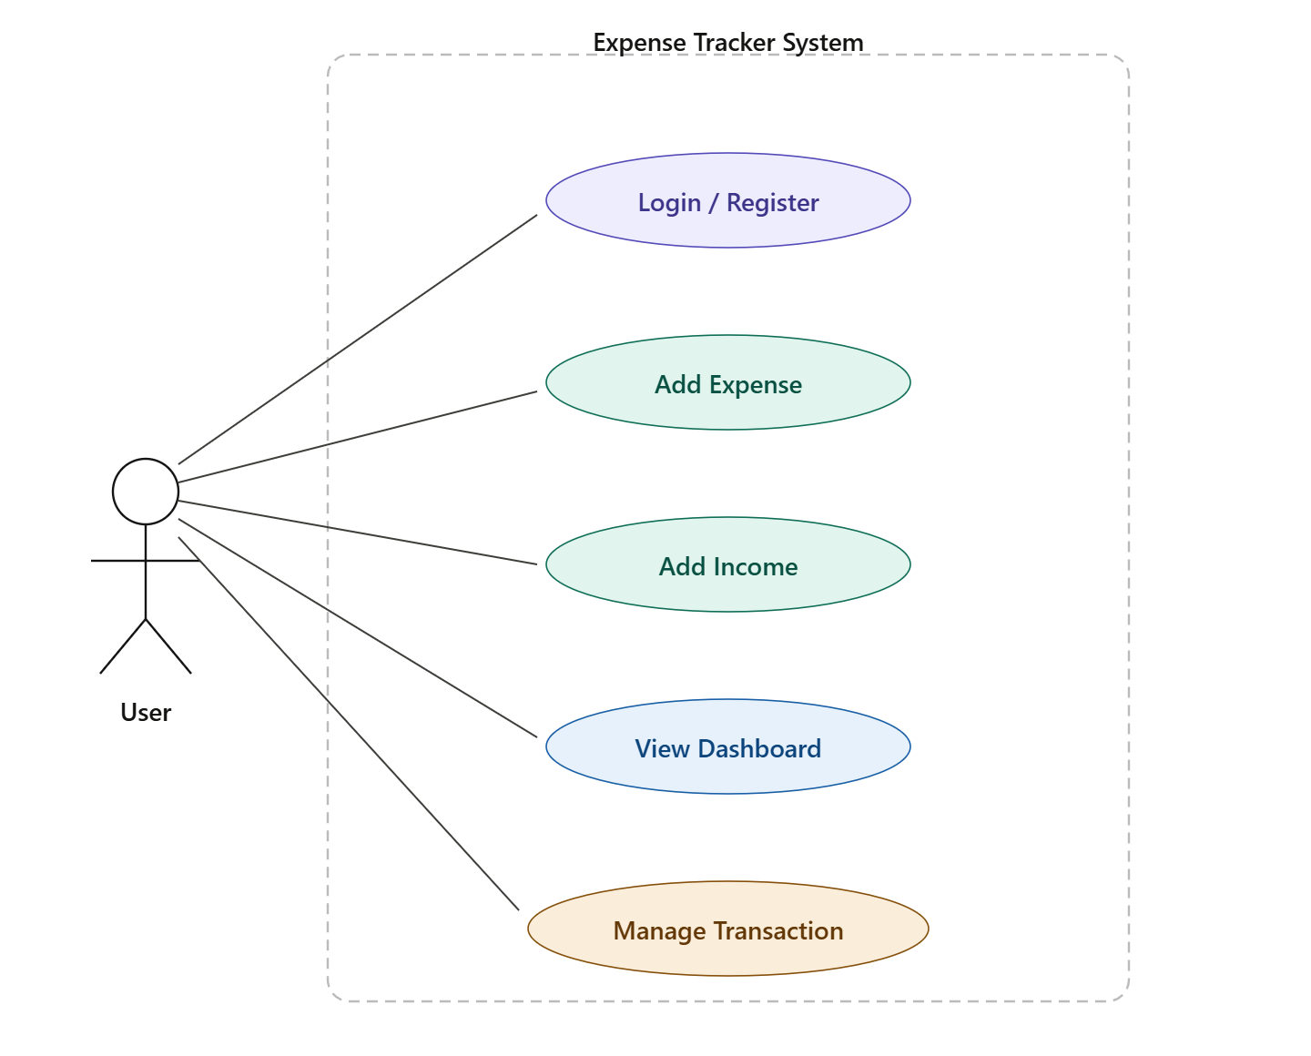

  - ENTITY RELATIONSHIP DIAGRAMS
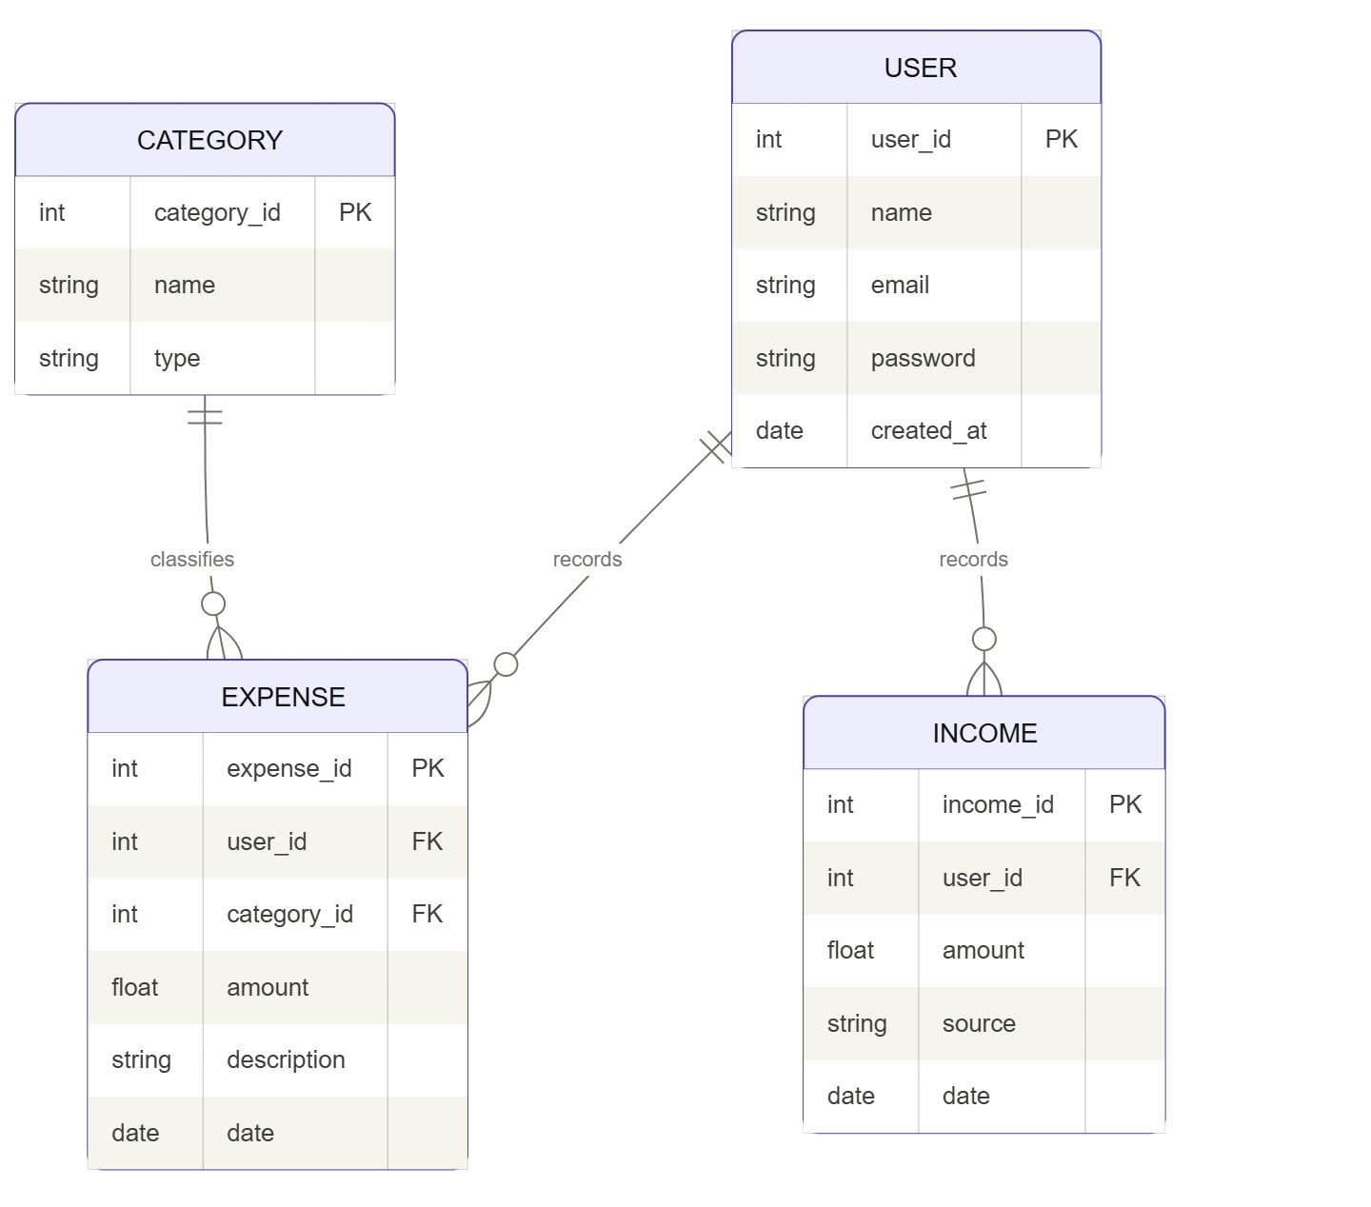

  - DATA FLOW DIAGRAMS

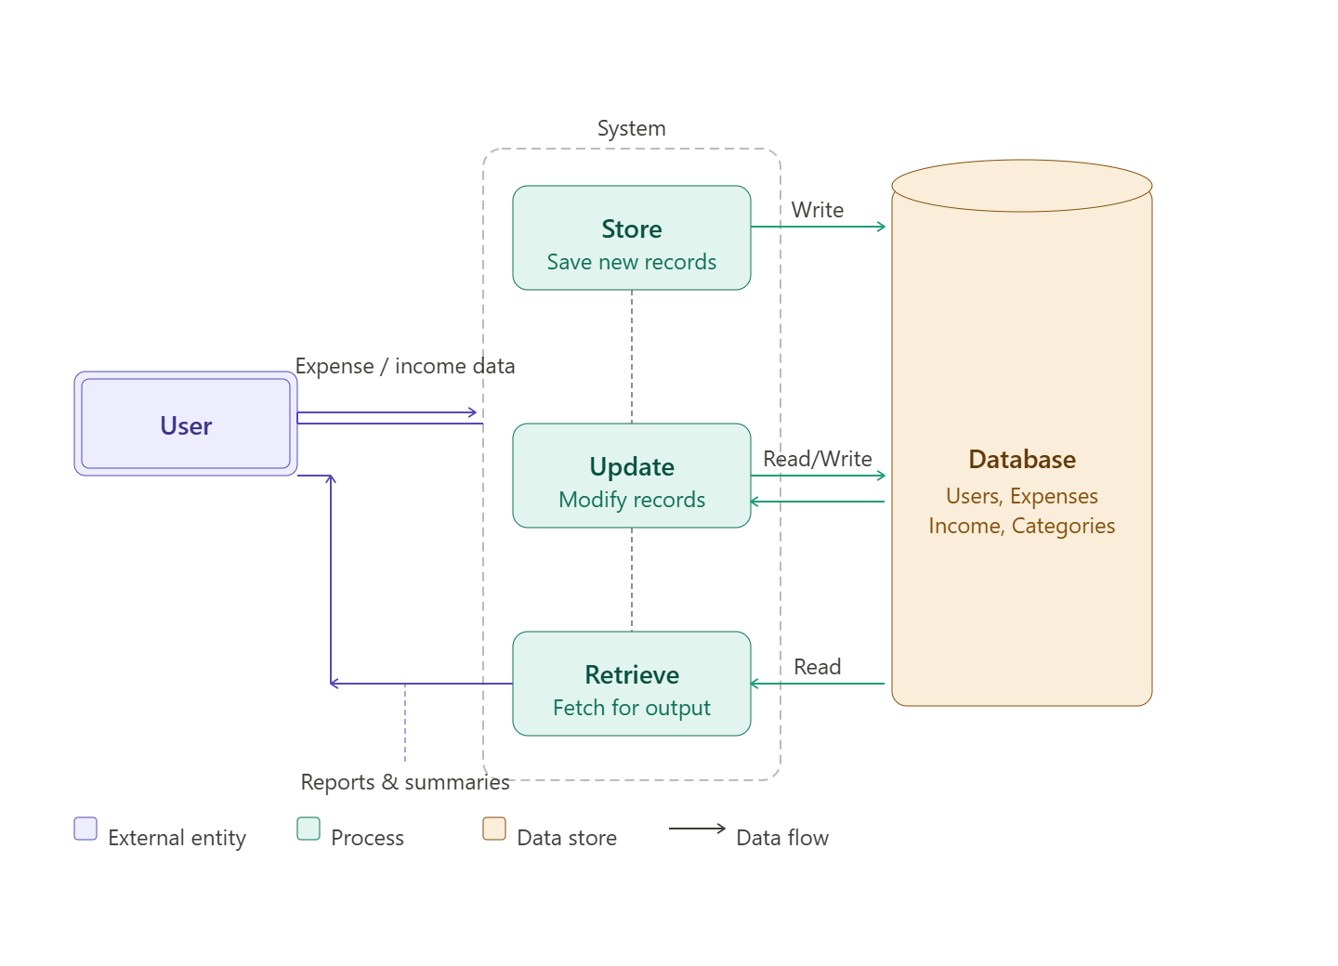
- MODULE DESCRIPTION USER LOGIN
Users can log in securely using their credentials.

ADD EXPENSE
Users can add daily expenses with details like amount, category, and date.

NEW INCOME
Users can record income sources and amounts.

VIEW DASHBOARD
Displays summary of total income, expenses, and balance.

MANAGE TRANSACTIONS
Users can update or delete existing records.

LOGOUT
Users can securely exit the system.

- IMPLEMENTATION
The system is implemented using a full-stack approach. The frontend provides an interactive interface for users, while the backend processes requests and communicates with the MongoDB database.

The application ensures efficient data handling, fast response time, and smooth user experience. CRUD operations (Create, Read, Update, Delete) are implemented for managing financial records.

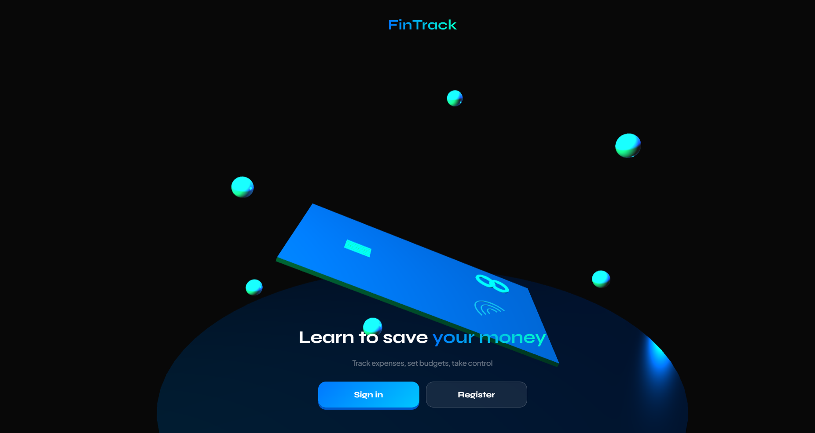

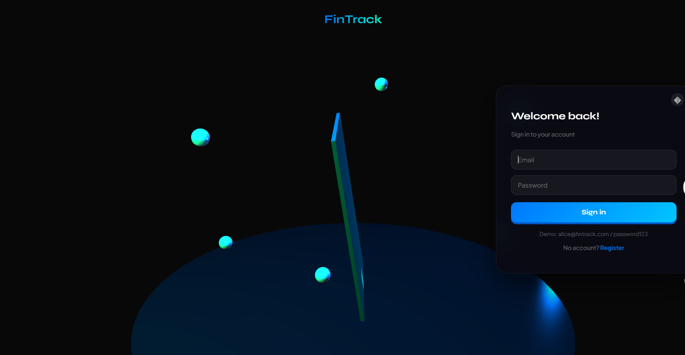

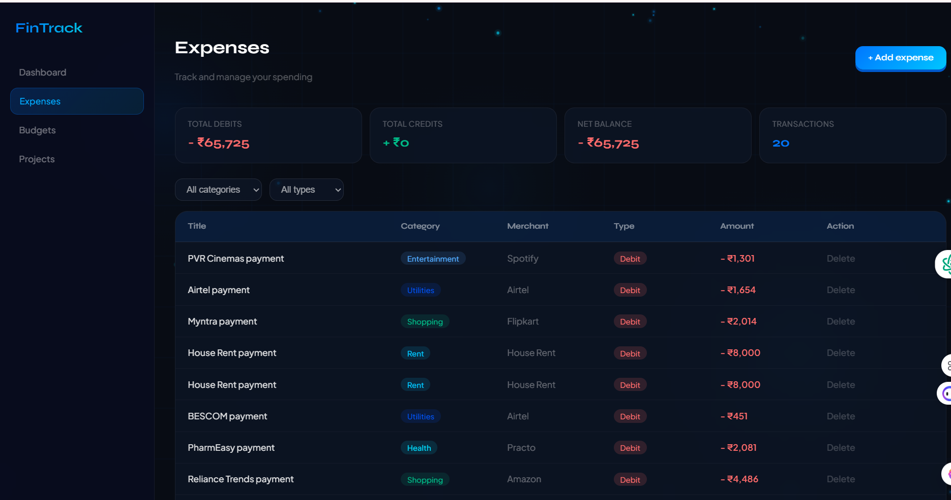

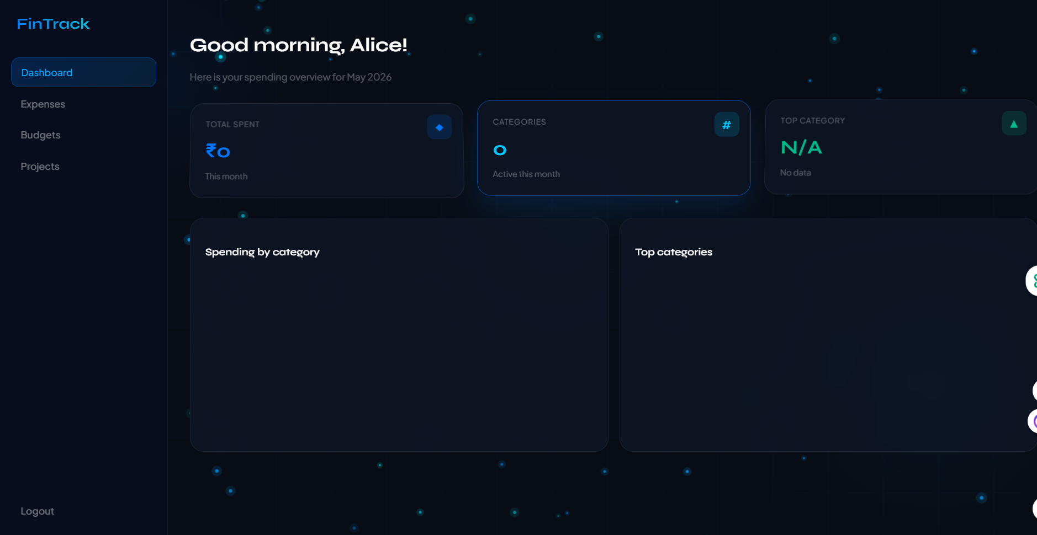

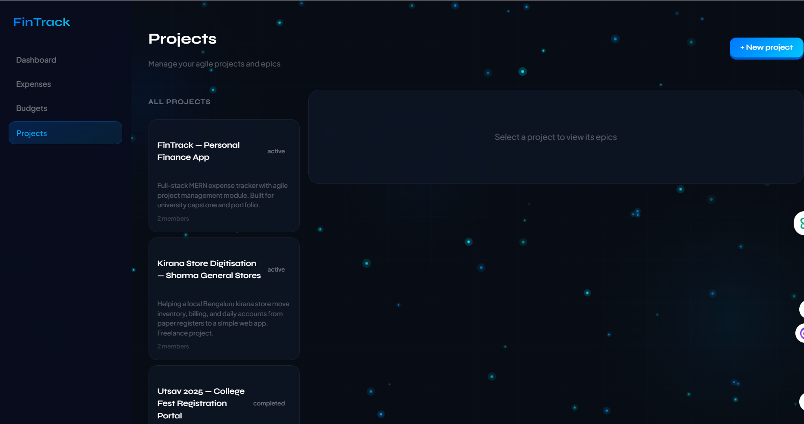

4.2 DATABASE DESIGN

The database is designed using MongoDB, a NoSQL database that stores data in JSON-like documents. This allows flexible and scalable data management.
Collections include:
    - Users
    - Expenses
    - Income
The design ensures minimal redundancy, efficient data retrieval, and consistency.
.

4.3 CODE

  - JAVA LOGIN PAGE CODE

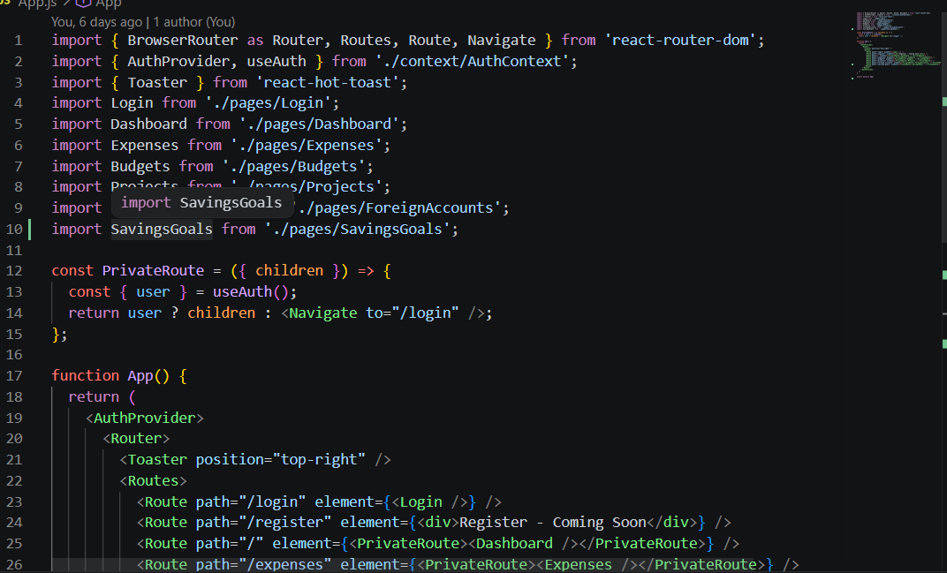
  - SEED CODE
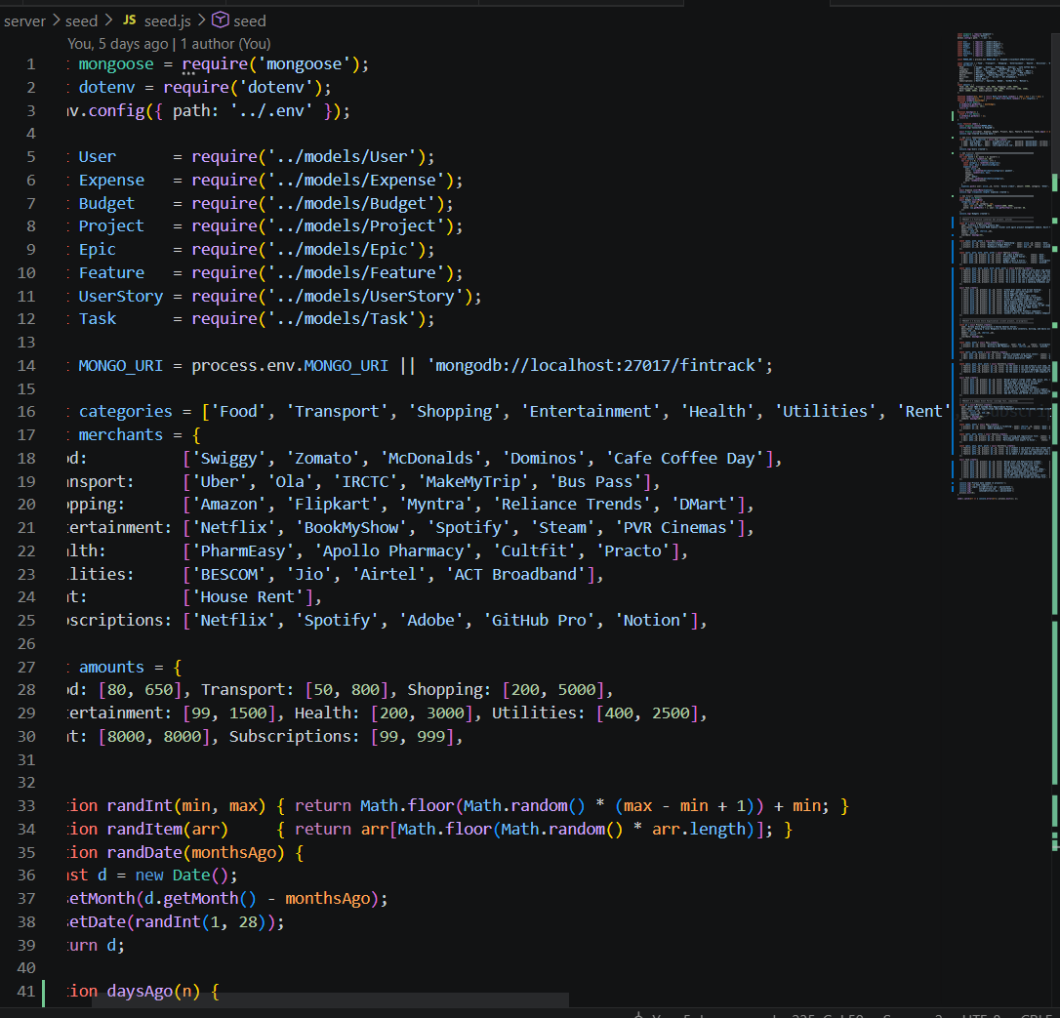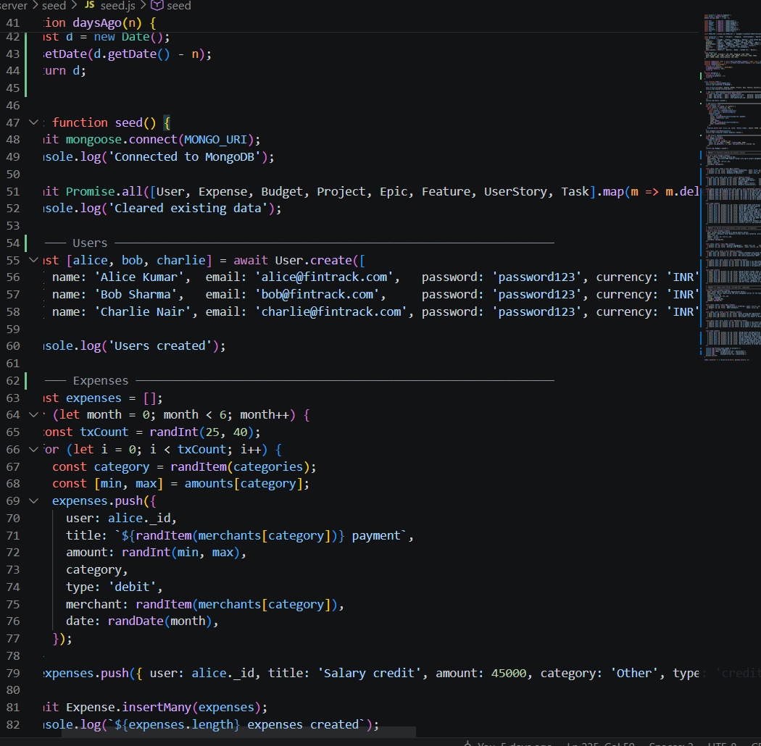

3.JSON CODE
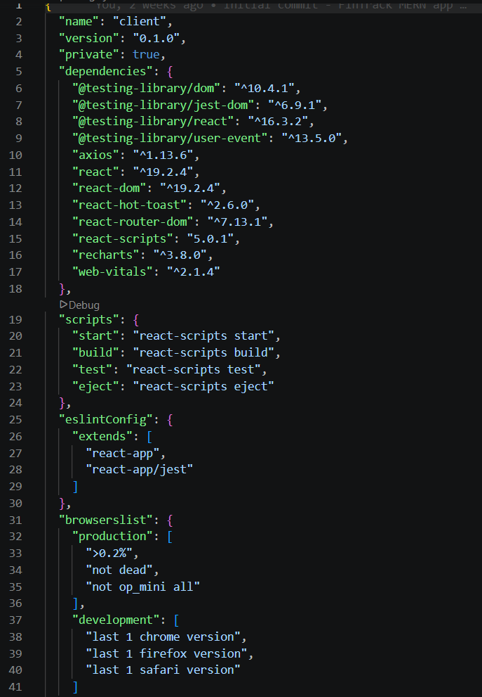

  - CONCLUSION

The Expense Tracking System successfully provides a reliable and efficient solution for managing personal finances. It simplifies the process of recording and analyzing financial transactions, reduces manual effort, and improves accuracy.

By using MongoDB and modern web technologies, the system ensures scalability, flexibility, and fast performance. The project demonstrates the practical implementation of database management and full-stack development concepts in solving real-world problems.

  - REFERENCES
- MongoDB Official Documentation
- Node.js Documentation
- Express.js Guide
- React.js Documentation
- W3Schools – Web Development Tutorials

